Sprint 4 documentation
Group members;
- Lucie King (A00011608)
- Bahar Gencyigit (GEN23588035)
- Aderinola Animashaun (ANI21505735)
GitHub Repository: https://github.com/Gencyigb/Cultural-connections
Task Board: https://github.com/users/Gencyigb/projects/1/views/1

Application Idea Summary

What is Cultural Connections?
Cultural Connections is a web based platform designed to bring people together
through cultural exchange. Users can share their cultural backgrounds, traditions,
recipes, languages, and customs with a global community.

What is the core purpose?
Our platform enables users to:
- Share posts about peoples traditions and customs
- Browse content by category
- Connect others who share similar cultural interests
- Learn about different cultures through authentic user-made content

Theme Alignment
Our project addresses the theme of sharing, exchange and building community by:
- Emphasising non-financial cultural exchange
- Building and maintaining a respectful and inclusive global community
- Encouraging mutual understanding through shared experiences

Sprint 4 user stories

Login and authentication
ID | User Story | Status
USER-LOGIN1 | As a user, I want to be able to create an account so  I can join the community | DONE
USER-LOGIN2 | As a user, I want to login  with my email and  password so I can access my profile | DONE
USER-LOGIN3 | As a user, I want to be able to log out so my account is secure | DONE

External API
ID | User Story | Status
USER-API1 | As a user, I want to see a  countries flag next to usernames | DONE
USER-API2 | As a user, I want to see  country information on profiles | DONE

DevOps and CI/CD
ID | User Story | Status
USER-DEVOPS1 | As a developer, I want the app to run consistently in docker | DONE
USER-DEVOPS2 | As a developer, I want to be able to refresh the website when changes have been made. | DONE

Categories page
ID | User Story | Status
USER-CAT1 | As a user, I want to browse content by category | DONE
USER-CAT2 | As a user, I want to see popular countries and tags | DONE

User lists page
ID | User Story | Status
USER-USER1 | As a visitor, I want to view popular community members | DONE
USER-USER2 | As a visitor, I want to click on a user to see their profile | DONE

User profile page
ID | User Story | Status
USER-PROF1 | As a visitor, I want to view detailed user information | DONE

Posts list page
ID | User story | Status
USER-POST1 | As a visitor, I want to browse all cultural posts | DONE
USER-POST2 | As a visitor, I want to see post previews before clicking | DONE

Post detail page
ID | User story | Status
USER-POST3 | As a visitor, I want to read full post content | DONE
USER-POST4 | As a user, I want to rate posts using a star system. | DONE

Application screenshots
Homepage
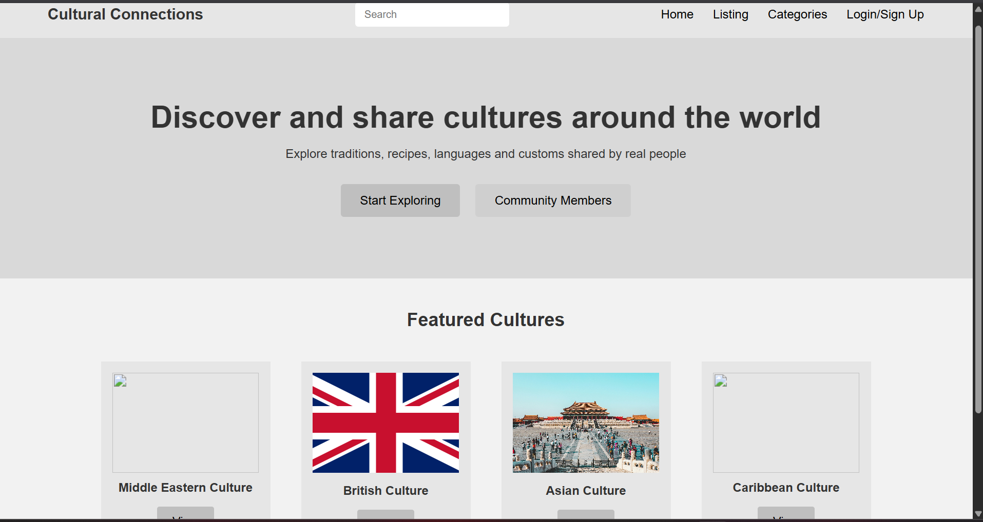
Categories page
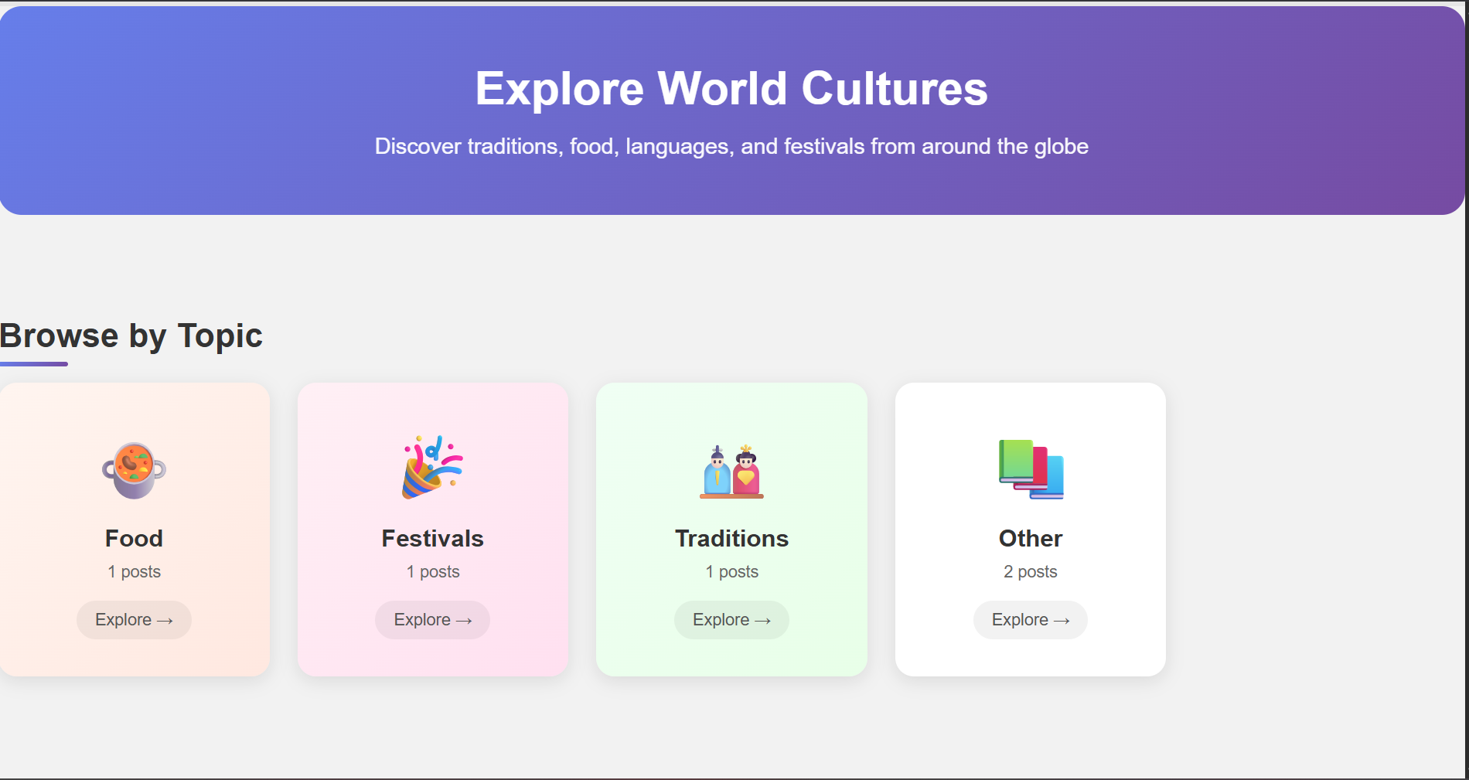

User list page
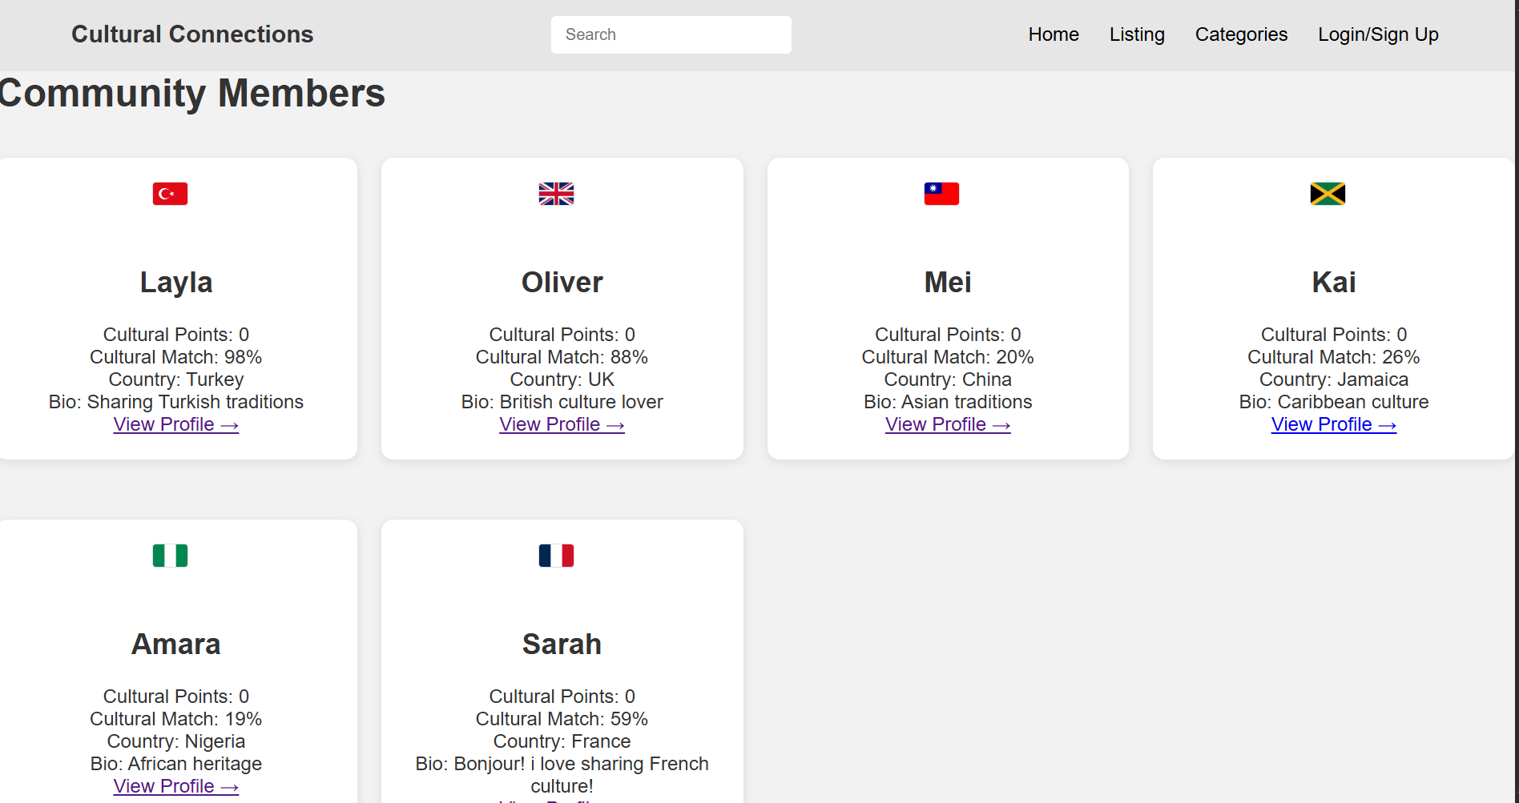
User profile page
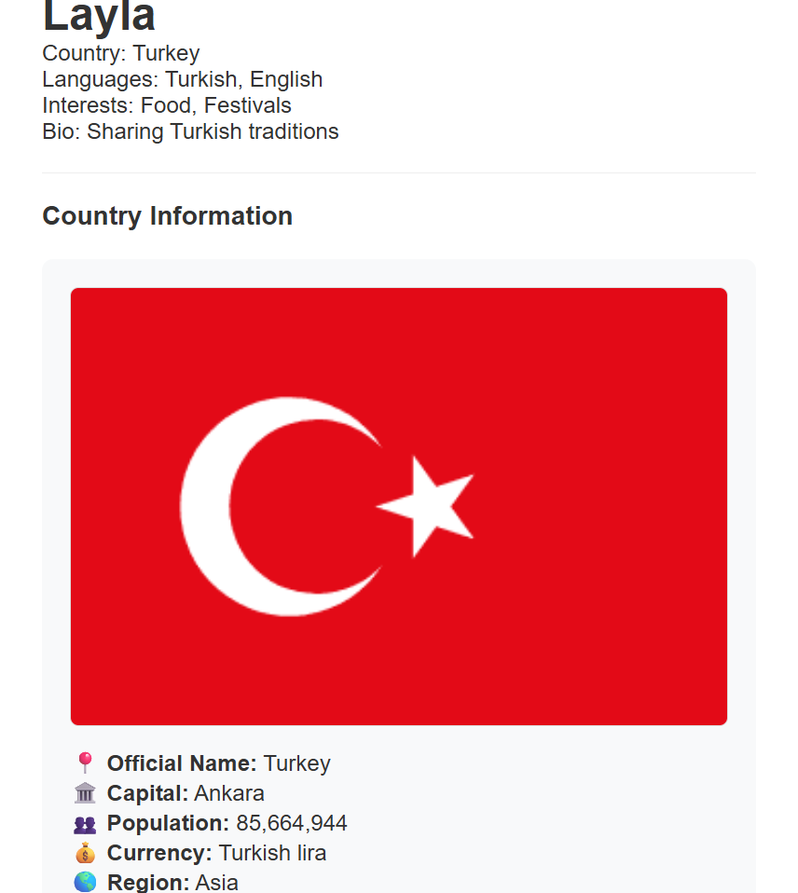

Post detail page
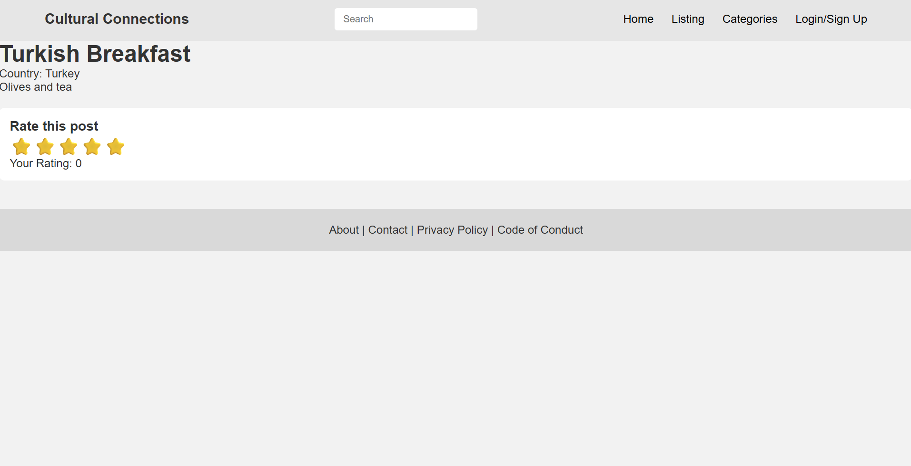
Login page
INSERT SCREENSHOT HERE!!!!!!!!!!!!

